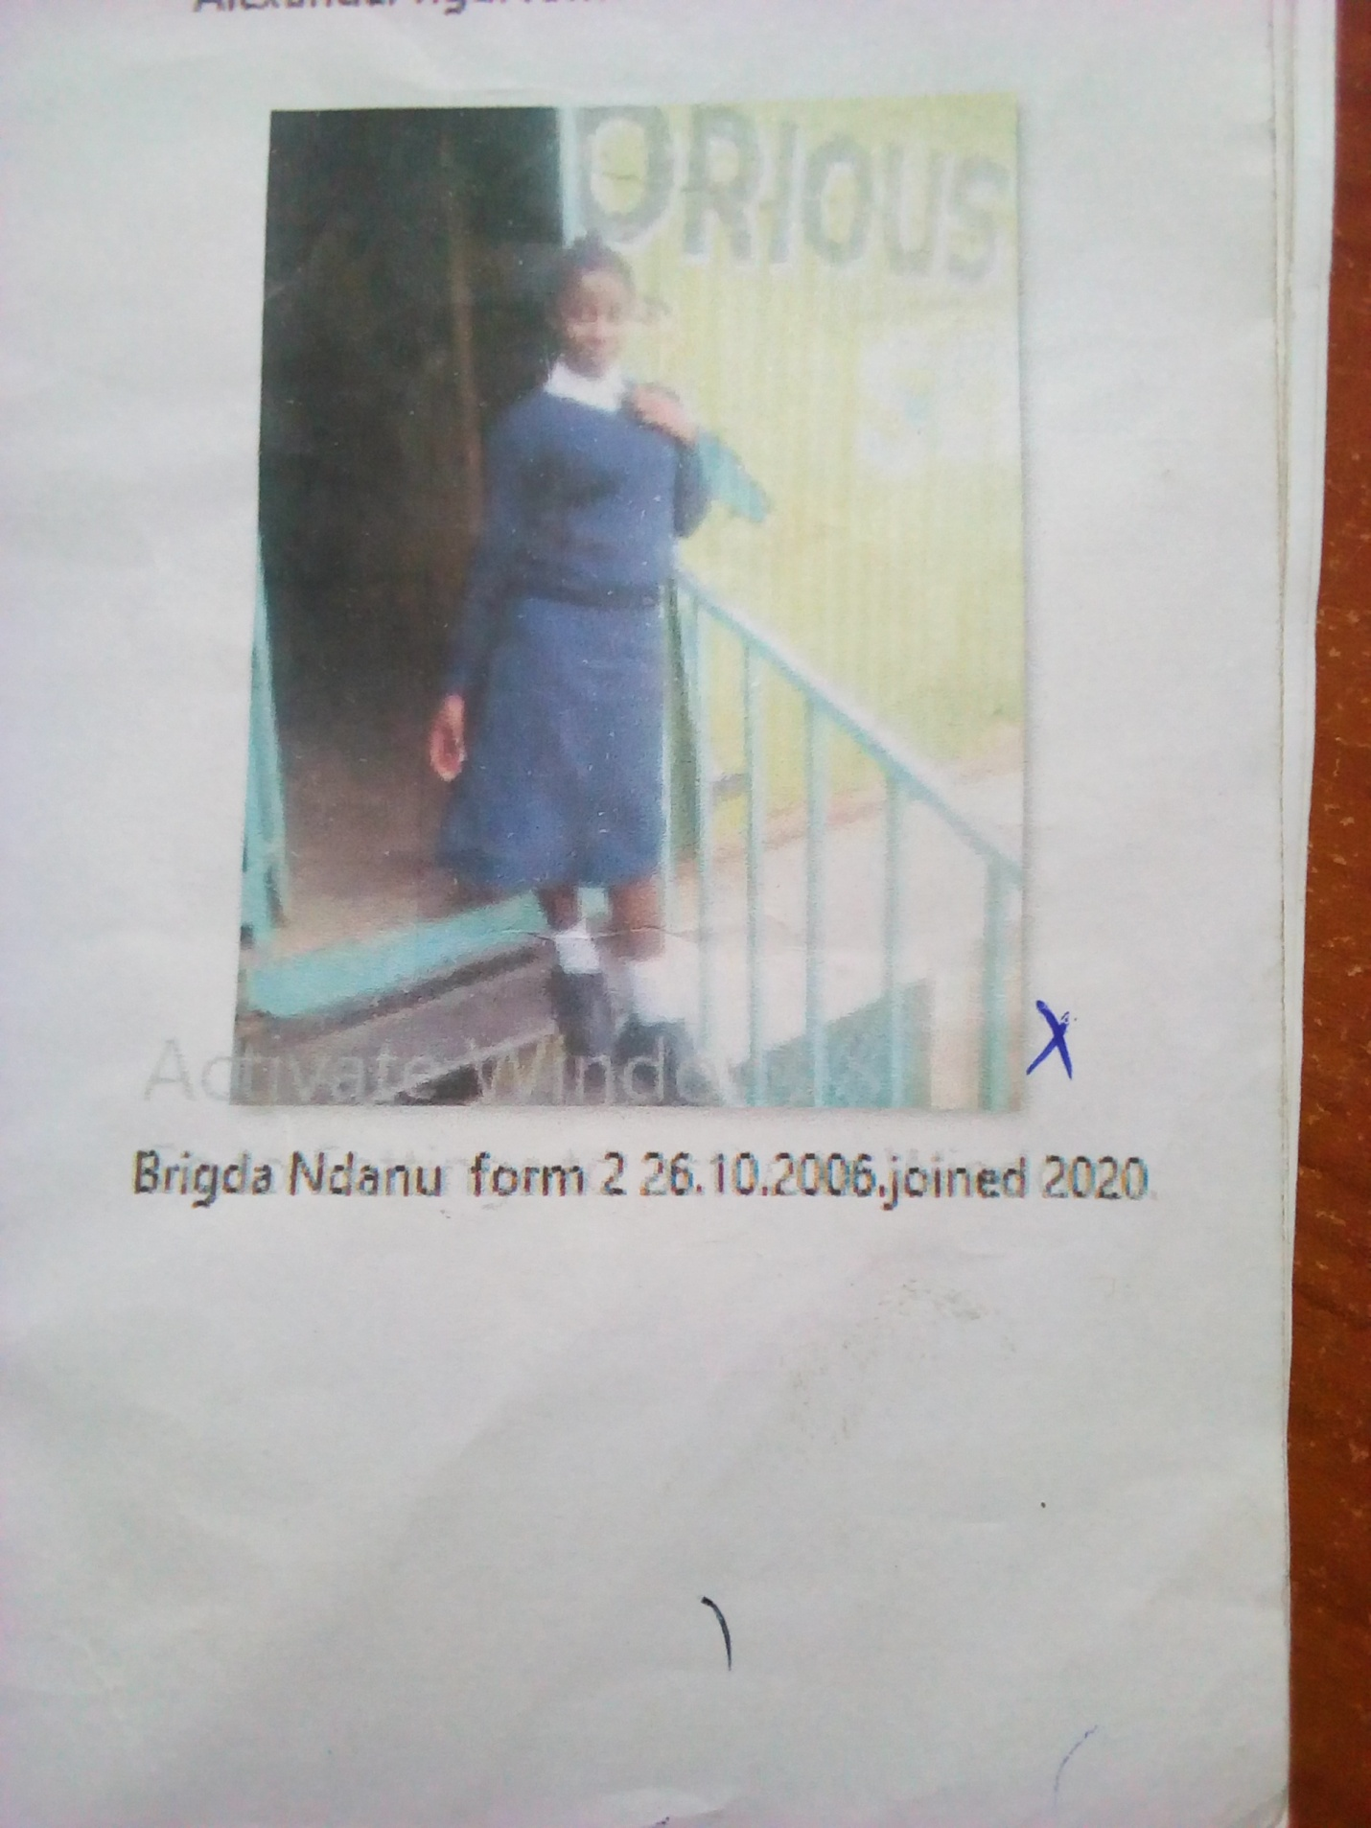
BRIGDA NDANU FORM 2 BORN 2006 JOINED 2020
Brigda 14 years was enrolled in our school when he was 14 years old. Brigda is an orphan girl, her parents died of HIV. She was left with no one to take care of her. When time for joining form one came she had no one in mind. She sought help at Glorious school. She was accepted in school after the Director was contacted.
Thanks to the Director Mr. Boniface Mangeti who allowed Brigda in school. I am now learning in glorious at least I have a place I call home praying that one day God will help our school have good classes, toilets and enough study materials. Thank you Michell and Brad for your support have really helped many in Mukuru

